**Information Radiator**

Information Radiators (aka. visual controls) are highly visible displays of information. Agile teams use information radiators to visualize progress in a very transparent way. Information radiators are in the public spaces and are easily accessible. Some of the information that can be found on an Information Radiator include:

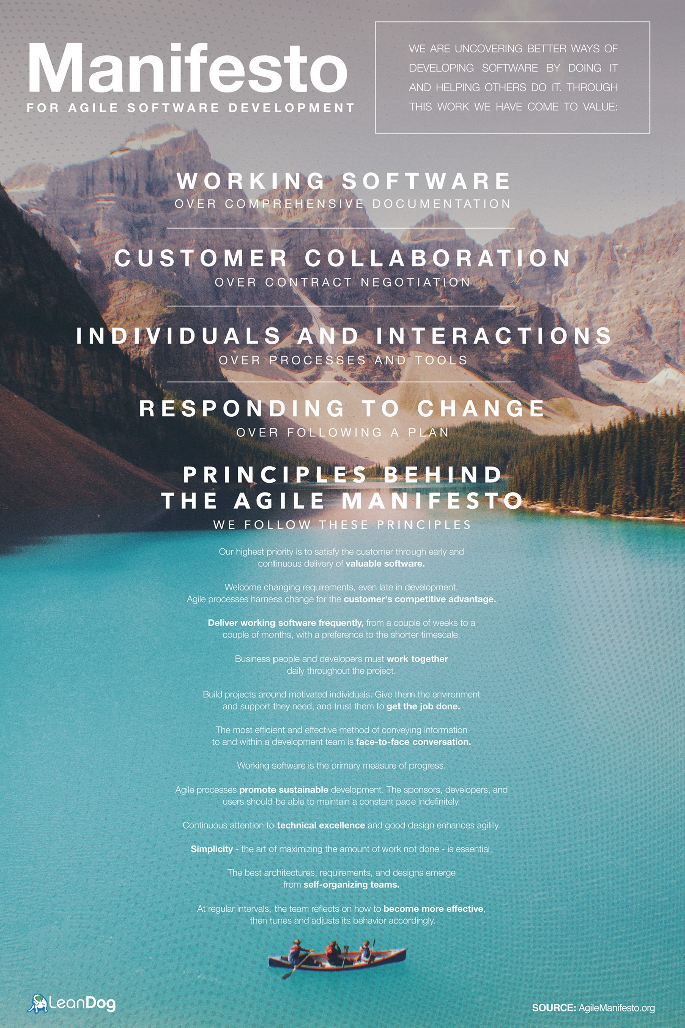

**Features delivered versus features remaining**

**Who is working on what**

**Retrospective outcomes**

**Current iteration stories/features to be developed**

**Velocity and defect assessments**

**Threats and issues for the project**

**Burn up and burndown chart**

**Story maps**

**Kanban board**

**Blocked work items**

**Release plans**

**Team rules**

Communication is one of major tools and techniques of agile. Under this topic we cover the agile communication genes that are the basic building blocks for any successful agile project like information radiators, team space, agile tooling, osmotic communication for collocated team, osmotic communication for distributed team and daily standup meetings. Apart from this, we will try to cover the communication etiquette.

1. **Information Radiators**

Information radiators provide an effective way to communicate project status, issues or metrics without a great deal of effort from the team. Information radiators started in the 1980s. The notion of "visual control" originating in the Toyota Production System is a precursor to "information radiators". In 1999, the term "Big Visible Chart" is coined by Kent Beck in Extreme Programming Explained, though later attributed by Beck to Martin Fowler. In 2001, the term "information radiator" is coined by Alistair Cockburn, part of an extended metaphor that equates the movement of information with the dispersion of heat and gas. The term is described and posted publicly, showing anyone walking by what is going on.

There are a variety of methods to choose from, including a whiteboard and markers, sticky notes, pins, dots or a combination of all of the above. Anything works, as long as it is not dependent on a computer and some fancy graphics software (unless it is distributed team). The major associated activity is updating the information radiator when the information changes. If you are using it to track tasks, it may change several times a day. If you are using it to track delivery of features, it may be updated once a week or every two weeks.

Information radiators can be static or dynamic. Static information radiators are fixed information that will not change over time, while dynamic information radiators will change over time and need regular updates to make it up to date with the latest data.

Static information radiators include information like labeling each person with a specific color, or each status with a specific color, etc.

Static Scrum Questions:

What have you done since the last scrum?

What are you planning to do before the next scrum?

Do you have any roadblocks?

Dynamic information radiators include:

Project status at a glance (completed, next release date, on time/behind or ahead of schedule)

Project Backlog

Iteration and release burn down charts

Project roadmap

Project Status: task tracking

Project Status: web application Kanban board

Optional information radiators can be used based on need:

Team vision statement

List of what was deployed to test

Dates of when the full quality team will be needed for testing (group testing dates/times)

Build status

Unit test coverage

Sprint goal

2. Team Space

A space to hold the daily stand-up, near where the iteration or Kanban board and graphs are prominently displayed. Apart from getting the entire team together in one room, there is one other subtle difference that distinguishes the room in which a team is sitting from the team room. The key is to work on the factors that foster communication and motivation, thus leading to productivity.

Team space can be of a futuristic space-turned-workspace with the added advantage of a space to hold an ad hoc team meeting, without having to reserve a conference room. Sound blocking walls or dividers separate the team from other teams or co-workers outside the team. Probably an intuitive way is to have a meeting held by having everyone turn their chairs. For pair programming, space to sit side by side at a computer rather than having to look over someone's shoulder, cramped in their cube. A brainstorming session between two developers should allow others to tune in or tune out without leaving their workstations.

While designing the work space with rich informative, check if the team should be able to access product plans, task lists, backlogs, charts and required source material. One should balance a lot of related factors like human, social, environmental, economic and personal. Also make sure there is plenty of available whiteboard space for brainstorming (not already used for charts).

An information radiator, also known as a Big Visible Chart (BVC), is a large graphical representation kept plainly in sight within an agile development team’s shared workspace. The term is generic rather than specific: information radiators can include most types of charts used in agile development. Burn down charts, burn up charts, task boards, planning boards and storyboards are among the possibilities.

An information radiator, also known as a Big Visible Chart (BVC), is a large graphical representation of project information kept plainly in sight within an agile development team’s shared workspace.

The term is generic rather than specific: information radiators can include most types of charts used in agile development. Burn down charts, task boards, planning boards and storyboards are among the possibilities. An information radiator is usually hand-drawn or printed but can also include computer-generated charts and electronic displays.

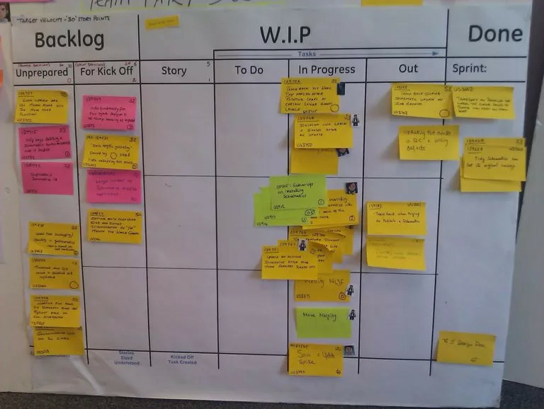

The purpose of information radiators is to help keep the team focused on what really needs their attention and to promote transparency.

Alistair introduced the term “information radiator” in his 2001 book, Agile Software Development. Martin Fowler is said to have coined the term “Big Visible Chart.”

What is an Information Radiator in Agile?

We typically think of radiators as items that emit some form of heat, light, or sound. When it comes to Agile information radiators, the idea is much the same, but information is being emitted. The goal of an information radiator is to highlight data in an easily digestible format.

The term ‘information radiator’ is attributed to Alistair Cockburn, one of the signatories of the Agile Manifesto. It is also known as a Big Visible Chart (BVC). To boost visibility, Agile teams place their information radiators in an easily accessible location. Think of it as a noticeboard outside a school assembly hall — it is placed where there will typically be plenty of footfall, so students and teachers are more likely to view important announcements. An Agile information radiator functions in a similar way: to highlight key information to Agile team members, project stakeholders, and other interested parties.

An information radiator is not a static item — it shows a team’s progress as it moves through an Agile project, so it will change regularly to incorporate updates.

According to the Agile Alliance, an information radiator can include ”handwritten, drawn, printed, or electronic displays.” Burndown charts and velocity charts are two of the most commonly used reporting tools.

When using information radiators, Agile teams can align them with their chosen project management framework, such as Kanban or Scrum.

Kanban board vs. Scrum board

A Kanban board is perhaps the most well-known example of an information radiator. It places cards or sticky notes into separate columns to denote project progress. For example, the left-hand column could be ‘Planned,’ the middle column could be ‘In Progress,’ and the right-hand column could be ‘Completed.’

Scrum boards can include similar progress columns but work in more timeboxed periods known as sprints. They also identify defined team roles, such as product owner and Scrum master.

**Information radiator vs. information refrigerator**

An information refrigerator is the exact opposite of an information radiator. In a refrigerator, you have to root around to find what you are looking for. The information will be stored somewhere, but, unlike an information radiator, it is not instantly visible. Extra effort is required to find items that may be hidden at the back. In information radiators, Agile project data is always front and center.

Why use an Agile information radiator?

An information radiator can be a good motivational tool for Agile teams. They will likely be using digital technology to store their information, but a large chart will offer a bird’s-eye view of progress. Rather than making a conscious effort to check their progress online, a team member can simply glance at an information radiator to be reminded of how far they’ve come in a project.

Information radiators add a level of transparency. The team’s workload is clearly displayed for everyone to see, which enables accountability. A BVC can also stimulate feedback, opening new communication channels between an Agile team and external stakeholders.

Break down information silos, and get important information out in the open.

When teams use information radiators effectively, they are more collaborative, transparent, accountable, and, ultimately, efficient. Key processes and workflows are pulled out of files hidden on servers and plastered on a wall to remove obstacles to productivity and communication.

Whether you are new to the information radiator concept, or your experience with them has not yielded the expected results, you’ll discover how to ensure your big visual charts carry out the agile principles and values to create your desired outcomes.

What is an information radiator?

An information radiator is a big visual chart placed in a prominent location. It conveys key information and shows the health of a team. It is used to visualize the flow of work, shows where bottlenecks (or blockers) occur, and enables anyone to see what the team is working on at any time.

Agile Information Radiator on Cork board

Each information radiator is unique, but common principles are used across the most successful ones.

What makes an effective or ineffective information radiator?

Not all information radiators are created equal. It’s not about throwing information on a wall in your office and declaring your team agile.

Agile Information Radiator example

These are the seven qualities of successful information radiators.

1. Effective information radiators are customized to the team—by the team; ineffective ones are rigid and prescriptive.

How do you create an information radiator? First, the whole team should make it together. It can’t be contrived by management and presented to the team as a finished product.

What should be included in the information radiator?

Each information radiator should be tailored to the team, but you can start with common boards and customize them from there:

Backlog board. This is the ultimate to-do list, an ordered list of tasks the team will work on over the next week and beyond. Prioritization of the backlog board is critical.

Work-in-progress (WIP) board. The WIP board shows what the team is actively working on. It may be a Kanban board featuring WIP limits and tasks pulled from column to column as the team has capacity. Or, for scrum teams, you’ll want a storyboard that shows your flow, including a backlog of stories to be completed during the sprint.

Calendar. This documents the team’s collective schedule of events—potentially including regular meetings, special events, or your sprint/iterations and ceremonies.

Artifacts or team documents. You may use a different term, but these are the documents that a team has agreed upon together. It often includes a working agreement, a definition of ready, and a definition of done.

Obstacle board. Since an information radiator should express what’s in progress, an obstacle board can clearly show what is creating roadblocks. With an obstacle board, management can walk past and immediately understand what’s holding the team up, creating a dialogue to overcome these issues.

While these boards are a good place to start, an information radiator must be personalized. It’s only effective if the information is relevant to the team.

Adding a postit sticky note to an agile information radiator

2. Effective information radiators only display the most important information; ineffective ones are overly detailed.

To be useful, an information radiator must strike a balance between comprehensiveness and simplicity. As the team designs the boards, if a concept is considered “nice to have” vs. “a must have,” skip it. Overly-detailed boards can become a chore for the team, or will be ignored in time.

Also, by limiting the information radiator to the most important information, it focuses conversation on the things that matter. These conversations enhance collaboration and keep everyone on the same page.

3. Effective information radiators are simple; ineffective ones are unnecessarily complex.

When it comes to design, the information radiator must be simple. As a tool of collaboration and a conversation starter for executives and colleagues outside of the team, anyone should be able to quickly understand it.

Why? Because we want the visual tool to create conversation, and complexity can inhibit this. We also want it to be quick to review, not a time-intensive task.

Example information radiator including events

4. Effective information radiators are big and visible; ineffective ones don’t stand out.

Literally, your information radiators need to be big. They need to be a can’t miss piece of art on your wall.

Your information radiator should have the same effect. Your team, management, and executives should stop when they see the big visual charts, encouraged to think about the story it tells.

5. Effective information radiators are regularly updated; ineffective ones go stale.

Just like that sticky note you’ve had stuck next to your computer with an “important” reminder for months, if your information radiator is stagnant, it loses effectiveness. Without regular updates, teams stop reaping the benefits of a big visual chart.

How do you make sure it remains regularly updated?

Everyone should have a defined role for updating the board. For example, it’s the product owner’s job to prioritize the backlog, developers must move their own stories through the WIP board, and everyone contributes to the obstacle board as needed. These roles create accountability across the team.

Revisiting the boards should be part of your regular retrospective or review process. Whatever your process for working, your team should regularly analyze those processes in order to continuously improve. A discussion about information radiators should be a part of that.

6. Effective information radiators change as the team changes; ineffective ones don’t.

By revisiting the information radiator’s effectiveness regularly, you ensure that it never becomes outdated. This is especially necessary as the team’s makeup or it’s processes change.

For example, if the team realizes it needs to shift its process from Scrum to Kanban, the board must be updated accordingly. Or, if a new team member is added or removed, the working agreement may need to shift to accommodate.

This all comes back to a crucial information radiator best practice: Information radiators must be customized by the team and for the team.

7. Effective information radiators are handmade, or are entirely visible (if digital); ineffective ones require effort to see completely.

For teams without existing software, we create hand-made information radiators, using sticky notes and other tangible tools. The tactile nature of moving a story from column to column as it approaches completion is rewarding. It also requires team members to get up and move around throughout the day, positively affecting productivity and overall happiness.

However, there are a suite of agile software platforms that are convenient for remote teams and have powerful capabilities to help teams work better.

To recognize the benefits of an information radiator while also using software, consider using a large screen or projector placed in the same location a handmade one would be. If you need to open up a separate file or zoom in and out of a giant digital “information radiator” on your laptop, it’s not an information radiator.

It must be large, highly visible and still follow the best practices outlined..

Information radiators are one narrow, but important tactic to achieving agile transformation.

* Backlog
* Work-in-progress
* Obstacles board
* Artifacts / Project Documents
* Who is working on what
* Retrospective outcomes
* Current iteration stories/features to be developed
* Velocity and defect assessments
* Threats and issues for the project
* Burn up and burndown chart
* Story maps
* Kanban board
* Blocked work items
* Release plans
* Team rules
* Agile Metrics.
* Calendar